**Assignment 10**

**Data Science Masters**

**We have the min and max temperatures in a city In India for each months of the year.**

**We would like to find a function to describe this and show it graphically, the dataset given below.**

**Task:**

**1. fitting it to the periodic function**

**2. plot the fit**

**Data**

**Max = 39, 41, 43, 47, 49, 51, 45, 38, 37, 29, 27, 25**

**Min = 21, 23, 27, 28, 32, 35, 31, 28, 21, 19, 17, 18**

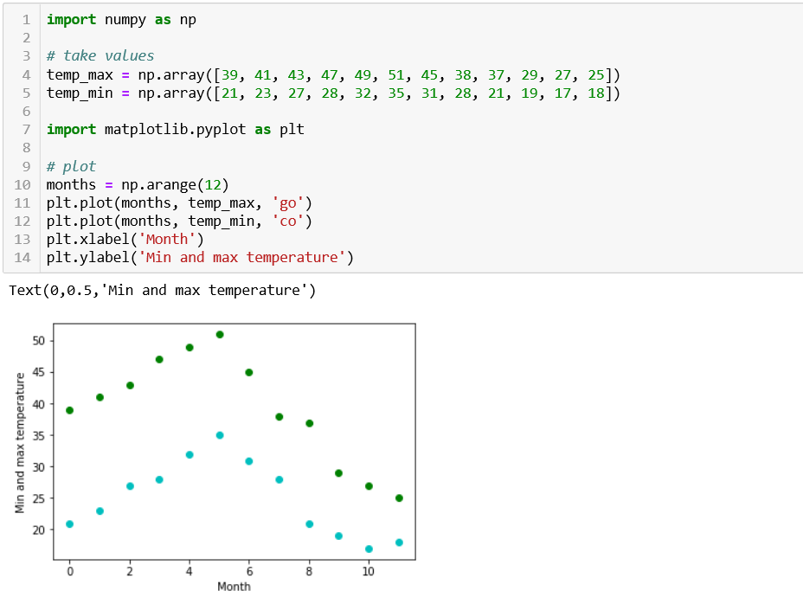

**Cont…..**

